EMTH1019 Linear Algebra and Statistics for Engineers

Workshop 2 solutions

Question 1

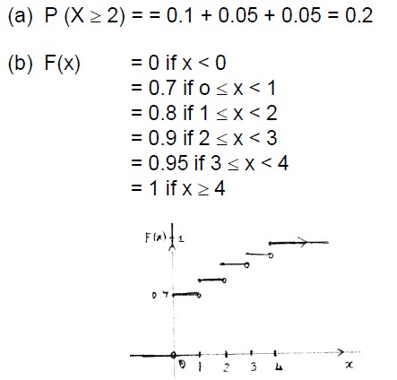

Question 2

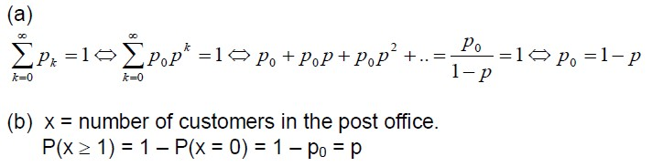

Question 3

(a)

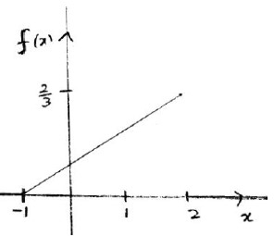

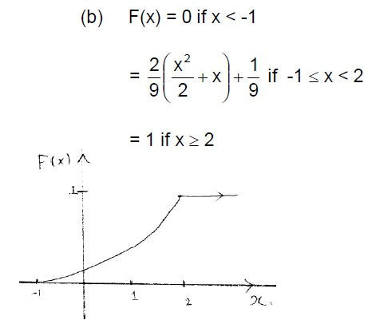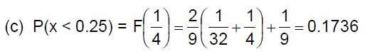

Question 4

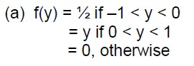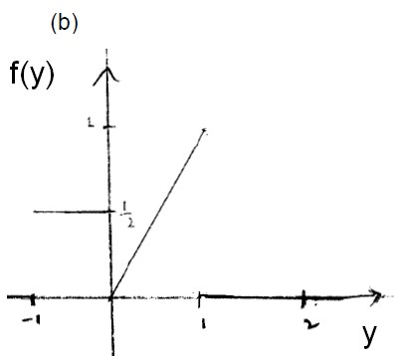

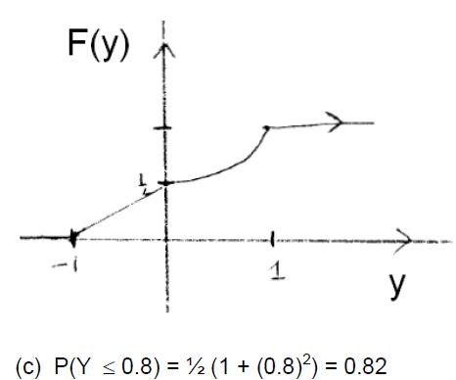

Question 5

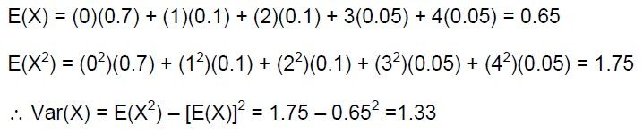

Question 6

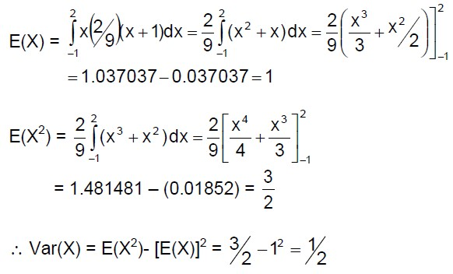

Question 7

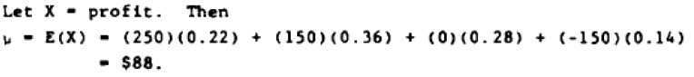

Question 8

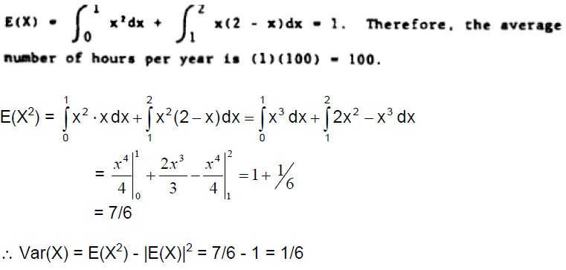

Question 9

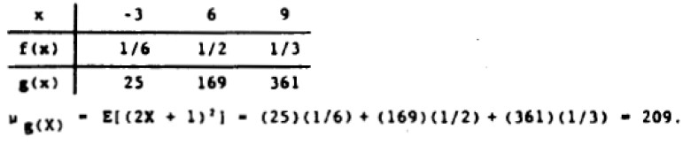

Question 10

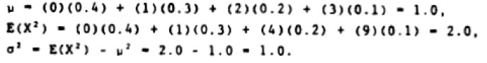

Question 11

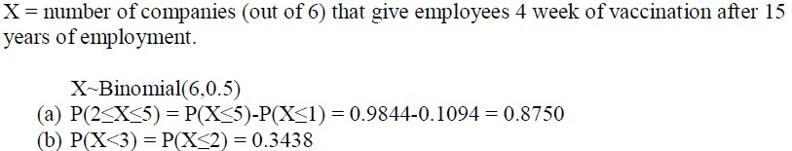

Question 12

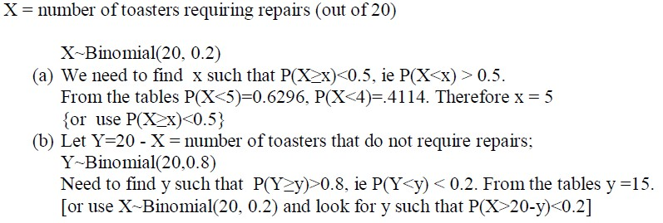

Question 13

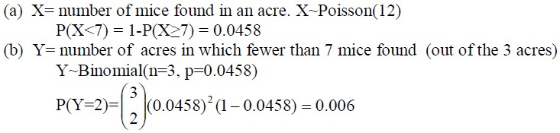

Question 14

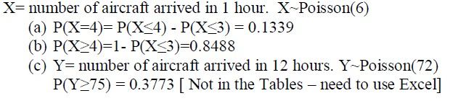

Question 15

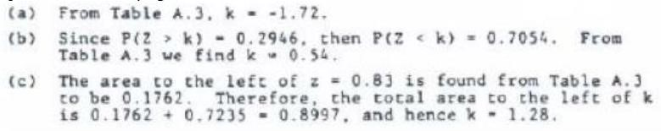

Question 16

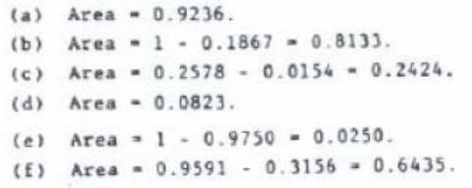

Question 17

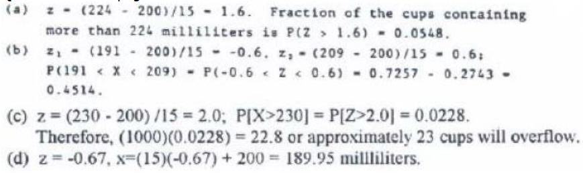

Question 18

a. The average strength 𝑋̅ has approximately a normal distribution with mean 𝜇 = 14 and standard deviation $\frac{σ}{\sqrt{n}}=\frac{2}{\sqrt{100}}$

𝑃(𝑋̅ > 14.5) = $P(\frac{\overline{x}-μ}{σ/{\sqrt{n}}}>\frac{14.5-μ}{σ/{\sqrt{n}}})$

is approximately equal to

𝑃 (𝑍 > 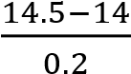) = 𝑃 (𝑍 > ) = 𝑃(𝑍 > 2.5) = 0.0062.

b.

$P\left(μ-1.96*\frac{σ}{\sqrt{n}}≤\overline{X≤}μ+1.96*\frac{σ}{\sqrt{n}}\right)=0.95$

𝜎 𝜎

For a normally distributed 𝑋̅. In this problem,

$$μ-1.96*\frac{σ}{\sqrt{n}}=14-1.96*\frac{2}{\sqrt{100}}=13.6$$

and

$μ+1.96*\frac{σ}{\sqrt{n}}=14+1.96*\frac{2}{\sqrt{100}}=14.4$

Hence, approximately 95% of sample mean fracture strengths, for samples of size 100, should lie between 13.6 and 14.4.